AUTUMN BREAK HOLIDAY HOMEWORK
Class-6
Subject-ENGLISH
- Paragraph writing- My Best Friend.
- Formal letter writing(Leave Application)
- Notice writing- Found
- Write different types of Verbs (25)

Subject-SANSKRIT
Write holiday Homework write on A4size paper and submission date is 30/10/2023
शब्द रूपाणि-बालक,देव,बालिका
धातु रूपाणि-पठ्,गम्-लट् लड्लृट

Subject-HINDI
1= झासी की रानी कवि ता को सचि त्र लि खि ए
2= छुट्टि यों में हैदराबाद घमू नेजानेके लि ए अपनेमि त्र कोपत्र लि खि ए ।
3= दशहरा पर्व पर एक नि बधं (Essay )लि खि ए ।
Subject-MATHEMATICS
1.A polygon is a simple closed curve made up of line segments. Here, The line segments are the sides of the polygon. Any two sides with a common end point are adjacent sides. The meeting point of a pair of sides is called a vertex. The end points of the same side are adjacent vertices. The join of any two non-adjacent vertices is a diagonal.
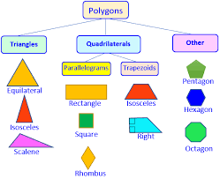
i) A polygon is a simple closed curve made up of…….
ii) Any two sides with a common end point are………
iii) The meeting point of a pair of sides is called a……..
iv) The join of any two non-adjacent vertices is a…………

Fractions
2. Ayushi is celebrating her 10th birthday .her father ordered a cake, snacks and cold drinks for her birthday. Ayushi’s aunty also ordered a cake. Now Ayushi have two cakes for her birthday. Ayushi invites her 5 best friends .Now they are total 12 members to celebrate her birthday. If the weight of the cake ordered by her father is 4kg and the weight of cake ordered by her aunty is 3kg
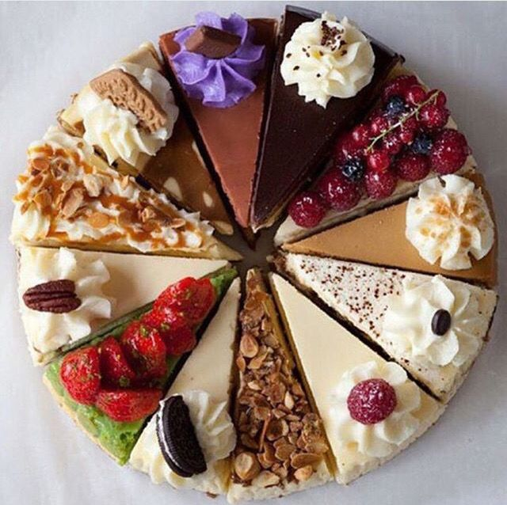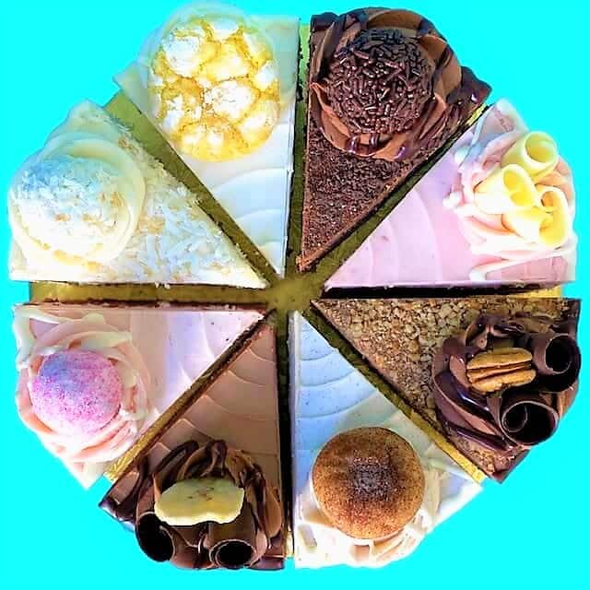
CAKE 1 CAKE 2
1. If two pieces from cake 1 consumed by Ayushi, so what fraction is ate by Ayushi?
2. How much weight of cake 1 is consumed by Ayushi?
3. What fraction of cake 1 is remaining?
4. If cake 2 is equally divided in to her friends then what fraction will each one get?

Subject-SCIENCE
WRITE AND LEARN
1. Define – Adaptation, Habitat, Stimuli, Terrestrial habitat, Aquatic habitat.
2. How are cactus adapted to survive in a desert?
3. Write the adaptations of fish.
4. Write the adaptations of an aquatic plant Lotus.
5. Write any 5 differences between Living and Non living things.
6. Paste the pictures of Plants and Animals of Desert habitat, Aquatic habitat, Mountain habitat.
7. Learn the spellings of key words of this chapter

Subject-SOCIAL STUDIES
SPL– WRITE THE FUNCTIONS OF MUNCIPALITY HOW IT GETS ITS FUNDS.
GEOGRAPHY— ON A OUTLINE WORLD MAP LOCATE ALL CONTINENTS AND OCEANS AND WRITE ABOUT IT.
HISTORY- WHAT ARE THE EFFECTS OF WARS.

Subject - Computer
Make a pamphlet or a collage on the following topics according to your roll numbers:
Roll no. Topic
1-10 Latest Memory Devices
11-20 Latest Output Devices
21-30 Latest Input Devices
31-40 Types of printer
41 onwards Latest Hardware

AUTUMN BREAK HOLIDAY HOMEWORK
Class-7
Subject-ENGLISH
- Write Dialogue writing between a Fan and a Girl/Boy.
- Write 2- Book Reviews.
- Write 2 examples of Applications.
- Write 2 examples of Informal Letter writing.
- Maintain Learner’s Diary for Term-II

Subject-SANSKRIT
Write holiday Homework write on A4size paper and submission date is 30/10/2023
शब्दरूपाणि-
एतत्,तत्,किम्-तीनो लिंगों में
धातुरूपाणि-कृ,भू,चल्-लट् लड् लृट लकार में रूप लिखो।

Subject-HINDI
1= भारत के दस राज्यों के प्रसि द्ध व्यजं न ( भोजन) के बारेमेंसचि त्र लि खि ए।
2= बाल महाभारत के पाठ "इंद्रप्रस्थ "के प्रश्न - उत्तर लि खि ए।
3= बरुाई पर अच्छाई की जीत का पर्व " दशहरा" पर एक अनच्ुछेद लि खि ए।

Subject-MATHS
INSTRUCTIONS: DO ALL THE HOMEWORK ON A-4 SHEETS.
1. Learn tables 1-25.
2.Complete your Learner's Diary. (Format is already in your class group)
3. Complete your Multi Disciplinary Project.
PROJECT TOPIC: TREES
FRAME WORK
• THE COVER PAGE
• CERTIFICATE
• ACKNoWLEDGEMENT
• INDEX
• CONTENTS- ACTIVITY-WISE (WITH PAGE NO:)

ACTIVITIES
•COLLECT INFORMATION REGARDING NUMBER OF TREES (COCONUT TREE,
MANGO TREE, JACKFRUIT TREE, PEEPAL TREE, BANYAN TREE,NEEM TREE ETC.)
FOUND IN YOUR LOCALITY (SCHOOLHOUSING COLONY ETC.)
•PRESENT THE COLLECTED DATA IN A TABULAR FORM FOLLOWED BY SUITABLE
GRAPHICAL REPRESENTATION (BAR GRAPH, PICTOGRAPH ETC.)
•ANALYSE THE DATA TO ANSWER THE FOLLOWING QUESTIONS
1. WHICH TREE IS FOUND MOST ABUNDANTLY?
2. WHICH TREE IS FOUND SCARCELY?
• PASTE THE PICTURES OF DIFFERENT TYPES OF PLANTS OR TREES GROWN IN YOUR AREA

Subject-SCIENCE
1) Learn hard words from lesson respiration, transportation and reproduction.
2) Learn question and answers from lessons respiration and transportation.
3) Make models of lungs and stethoscope.
4) In A4 paper draw the pictures of heart, excretory system, respiration
5) Prepare the questions for green Olympiad

Subject-SOCIAL STUDIES
GEOGRAPHY- TSUNAMI —
WRITE 2 PAGES ABOUT TSUNAMI
HISTORY- WRITE ABOUT NAYNARS AND ALWARS
CIVICS- FIVE LATEST NEWS PAPER CUTTING AND PASTE [EDUCATION RELATED]
Subject - Computer
Write down in homework side or make Microsoft words documents in these topics (20 MARKS FOR EACH STUDENTS ,IN INTERNALS MARKS WILL BE INCLUDED)
1. Threats to computers, viruses and their types 1- 3
2. Anti-virus software and examples 4- 7
3. Firewall and its use 8- 13
4. Cyber Crime and Computer Ethics 14-17
5. Hackers and crackers 18-21
6. Cyber law and its importance 22-26
7. Backup and restore 27-30 ONWARDS
HTML
1.Heading (H1 to H6) 1-3
2. Background colour 4-7
3. Font tag (Size, Face, Colour) 8-13
4. Text alignment (Centre, Left, Right) 14-17
5. Paragraph formatting tags 18-21
6. List tags 22-25
7. Order and un-order list 26-28
8. Background image 29-32
9. Image insertion in the webpage 33-35
10. Anchor tag with Hyperlink 36- ONWARDS

AUTUMN BREAK HOLIDAY HOMEWORK
Class-8
Subject-ENGLISH
- A Comic Script on lesson “This Is Jody’s Fawn”
- Write a Bio Sketch on Stephen Hawking.
- Write any 2 Formal/Informal letter writing.
- Write 2 stories with a suitable Title and moral message.
- Write 2-2 examples for all Tenses.
- Learn all the written work from English Notebook.
- Maintain Learner’s Diary for Term-II
Subject-SANSKRIT
Write holiday Homework write on A4size paper and submission date is 30/10/2023
शब्द रूपाणि-असमद् युष्मद,राजन् पितृ मातृ।
धातुरूपाणि-दृश् ,पच्,पा,हस् पंच लकारेषु।
Subject-HINDI
1= एक सेपचास तक हि दं ी गि नती लि खि ए।
2= वसतं ऋतुपर एक कवि ता लि खि ए।
3= छुट्टि यों में हैदराबाद घमू नेजानेके लि ए अपनेमि त्र कोपत्र लि खि ए ।
4= कोवि ड -19 पर एक नि बधं (Essay )लि खि ए ।
5= भारत मेंकौन कौन सी भाषाएंबोली जाती है, इसेपोस्टर पर बनाइए ।
6= भारत के प्रमखु ऐति हासि क स्थानों के नाम चि त्र सहि त लि खि ए ।

Subject-MATHS
INSTRUCTIONS: DO ALL THE HOMEWORK ON A-4 SHEETS.
1. Learn tables 1-25.
2. Learn the Squares of the numbers from 1-25.
3. Learn the Cubes of the numbers from 1-25
4. Learn and practice all the divisibility rules.
5. Complete your Learner's Diary. (Format is already in your class group)
6. Complete your Multi Disciplinary Project.
PROJECT TOPIC: HEALTH IS WEALTH
FRAME WORK
• THE CoVER PAGE
• CERTIFICATE
• ACKNOWLEDGEMENT
INDEX
• CONTENTS - ACTIVITY-WISE (WITH PAGE NO)
ACTIVITIES
• Prepare a Bar Graph / Pictograph for various nutrients found in your 5 favourite food items.
PRESENT THE COLLECTED DATA IN A TABULAR FORM FOLLOWED BY SUITABLE
GRAPHICAL REPRESENTATION (BAR GRAPH, PICTOGRAPH ETC)
Collect data of amount of various nutrients required by an adult daly.
Draw a pie chart on requirement of nutrients by an adult.
1. Find ratio of protein required by a person to its body weight.
2. Write ratio and percentage of protein found in 5 food items.
• PASTE THE PICTURES OF DIFFERENT TYPES OF FOOD ITEMS AND NAME THE

Subject-SCIENCE
- Conservation of plants & animals topic write question & answers, solve exercise
- After holidays test will be conducted on this topic

Subject-SOCIAL STUDIES
HISTORY-WRITE ABOUT ALL SOCIAL AND CASTE REFORMERS IN INDIA
WITE ABOUT NEP 2020
WRITE ABOUT THE PUBLIC FACILITIES PROVIDED BY GOVERNMENT
GEOGRAPHY-LOCATE ALL IRON AND STEEL INDUSTRIES IN INDIA
Subject – Artificial intelligence
POWER POINT PERSENATION ON THESE TOPICS
(20 MARKS FOR EACH STUDENTS ,IN INTERNALS MARKS WILL BE INCLUDED)
- IOT 1-5
- CLOUD COMPUTING 6-10
- ROBOTICS 11- 15
- AI AND IT’S DOMAINS 16-20
- AI APPLICATIONS 21-25
- SDG’S GOAL REALTE WITH AI 26-30
- GENERATIONS OF COMPUTERS/LANGUAGES 31-35
- AI ETHICS 36 ONWARDS

AUTUMN BREAK HOLIDAY HOMEWORK
Class-9
Subject-ENGLISH
- Complete MCB Units 5- Mystery and 6- Children
- Make a Comic Script. Scene: You are having toothache due to cavity and going to have medical treatment at Dental Clinic.
- Write 2 Diary Entries.
- Write 2 Stories with guided composition or picture. Give a suitable Title and moral message also.
- Complete assigned Portfolio.
- Write Poetic Devises for all poems covered in your class till 19th October.

Subject-SANSKRIT
Write holiday Homework write on A4size paper and submission date is 30/10/2023
पत्रलेखनम्-3चित्रलेखनम्-3 अपठित अवबोधनम्-3

Subject-HINDI
1= नीचेदि ए सभी वि षयों पर 100 शब्दों मेंनि बधं लि खे
(क) स्वच्छ भारत - सदंुर भारत (ख) जल हैंतो कल है।
2= अपनेभाई को जन्मदि न की बधाई देतेहुए एकबधाई पत्र लि खि ए।
3= "मेघ आए" कवि ता मेंप्रकृति का मानवीकरण का वर्णनर्ण कीजि ए।
4= भारतीय सस्ं कृति मेंत्योहारों का महत्व इस वि षय पर एक अनच्ुछेद लिखिए |
Subject-MATHS
1. What is the sum of all interior angles of a quadrilateral?
2.If four angles of a quadriletral are in the ratio of 1:2:4:5. Find the angles.
3.In a quadrilateral, if two angles are right angles and other two angles are in the ratio 1:2. Find the angles.
4. In a quadrilateral, if two angles are complementary and other two angles are in the ratio 4:5. Find the measure of these two angles.
5. Three angles of a quadrilateral are 49°,70°, and 121°. Find the fourth angle.
6. If four angles of a quadrilateral are ín the ratio 2:3:6:7. find the four angles.
7.In a llgm if, one angle is 90° then find the other three angles?
8.In the given figure find the value of x?

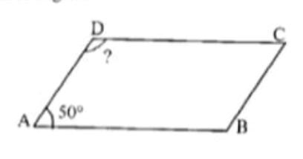
9.In the given figure.ABCD is llgm. Find angle D?

10.In the fig.PQRS is a llgm. Find x?
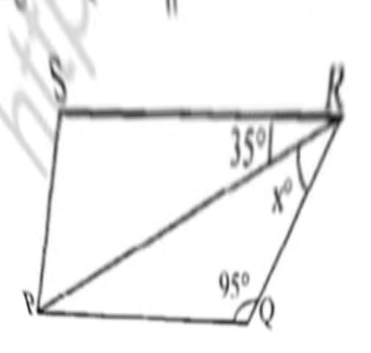
Subject-SCIENCE
1. Write the formula to find the magnitude of the gravitational force between the earth and an object on the surface of the earth.
2. Define acceleration due to gravity.
3. Why is the weight of an object on the moon 1/6 th its weight on the earth.
4. How does the force of gravitation between two objects change when the distance between them is reduced to half.
5. Why a heavy object does not fall faster than a light object?
6. If the moon attracts the earth, why does the earth not move towards the moon?
7. What do we call the gravitational force between the earth and an object?
8. Why will a sheet of paper fall slower than one that is crumped into a ball ?
9. A ball is thrown vertically upwards with a velocity of 49 m/s. Calculate
1. The maximum height of which it rises
2. The total time it takes to return to the surface of the earth
10. A ball is thrown up vertically returns back to the throwner after 6s.
Find (a) the velocity with which it was thrown up
(b) the maximum height it reaches.
(C) it’s position after 2s 11. Calculate the force of gravitation between the earth and thesun. Given that the mass of earth = 6 × 10²⁴ kg and of the sun = 2 × 10³⁰ kg. The average distance between the two is 1.5 × 10¹¹ m. PROJECT – submit the write up of an innovative project for science exhibition

Subject-SOCIAL STUDIES
Interdisciplinary project social science
1.Natural vegetation
2.Forest society and colonialism

Subject – Artificial intelligence
POWER POINT PERSENATION ON THESE TOPICS
(20 MARKS FOR EACH STUDENTS ,IN INTERNALS MARKS WILL BE INCLUDED)
- Introduction to AI 1 - 5
Excite
Relate
Purpose
Possibilities
AI Ethics
- AI Project Cycle 6-10
Problem Scoping
Data Acquisition
Data Exploration
Modeling
- Neural Network 11- 15
Understand and appreciate the
concept of Neural Network
through gamification.
- Introduction to Python 16-20
- Communication Skills – I 21-24
- Self Management Skills – I 25-29
- ICT Skills – I 30-33
- Entrepreneurial Skills – I 34-38
- Green Skills – I 38 ONWARDS

AUTUMN BREAK HOLIDAY HOMEWORK
Class-10
Subject-ENGLISH
- Complete assigned Portfolio.
- Make a Comic Script on poem “ A Tale Of Custard The Dragon”
- Make an attractive and informative Boucher on ”Coorge”
- Solve 2- Unseen Passages.
- Write 2 Analytical Paragraphs (diagram/graphics/picture/chart).
- Write 2 examples of letter to Editor.
- Write Poetic Devises for all poems covered in your class till poem “ A Tale Of Custard The Dragon”

Subject-SANSKRIT
Write holiday Homework write on A4size paper and submission date is 30/10/2023
पत्रलेखनम्, चित्रलेखनम् अपठित अवबोधनम्-4,4,४।

Subject-HINDI
1= शहनाई के बादशाह उस्ताद बि स्मि ल्लाह खान का सचि त्र जीवन परि चय लि खि ए ।
2=" वि ज्ञान का अवि ष्कार वरदान हैंया अभि शाप "मैंक्यों लि खता हूं पाठ के आधार पर लि खि ए।
3= " सि क्कि म मेंभौगोलि क, सामाजि क और आर्थि कर्थि जीवन आसान नहीं। है, साना साना हाथ जोड़ी पाठ केआधार पर लि खि ए।
4= गगं ा - जमनु ी सस्ं कृति सेक्या आशय है?

Subject-MATHS
- The roots of the equation $x^{2}+7x+12=0$ are
a) 3 and 4 b)-3 and 4 c)-3 and -4 d) 3 and -4
2. If p - 1, p+3, 3p -1 are in AP, then pis equal to
(a) -4 (b) 4 (c) 8 (d) -8
3.What is the midppint of a line with endpoints (3,7) and (11,-5)?
(a) (7, -1) b) (14-2) (c) (7, 1) d) none of these
4. Find the point on X-axis which is equidistant from (2, -5) and (-2,9 ).
5. Which term of the AP:3, 8, 13, 18………,is 78?
6. Find the value of k for which the quadratic equation 9$x^{2}$ + 8kx + 16 =0 has two real equal roots
7. Solve by using quadratic formula
40 + 3x -$x^{2}$ =0
8.How many terms of the AP: 24, 21, 18,…..must be taken so that their sum is 78?
9. Find the sum of first 24 terms whose nth term is given by an =3 + 2n.
10.A point P lies on line segment joining the point A(-4,3) and B(5,-2) IF of $\frac{PB}{AB}$ =$\frac{2}{5}$ find the coordinate
of P.
11.Solve three sets of standard and basic board sample papers.

Subject-SCIENCE
1. Explain the 5 types of chemical reactions with examples.
2. Write the chemical names, chemical formula, preparation methods and uses of the following substances – Bleaching powder, Baking soda, Washing soda, POP.

3. What happens when an acid reacts withMetals, Sodium bicarbonate, a base,
4. What are the properties of Ionic compounds. Explain it with reason.
5. What are the differences between Roasting and Calcination.
6. Draw the electron dot structure of the following compounds – Ethanol, Ethanoic acid, Propanal, Ethene, Ethyne.
7. Explain with chemical reactions – Esterification, Saponification
8. Explain the versatile nature of Carbon.
9. Name any 3 plant hormones and 3 human hormones and their functions.
10. Write the names of male and female reproductive parts and their functions.
11. Explain double fertilisation and triple fusion.
12. Draw the pathway of respiration
13. Draw the pathway for a reflex action.
14. Draw the flowcharts for a Monohybrid cross between a Tall and a Dwarf plant. And a Dihybrid cross between Round Yellow (RRYY) and Wrinkled green (rryy).
15. How is Ozone layer formed ? What is its function and how it is depleted? How can we protect ozone layer?
16. Explain rainbow formation with diagram.
17. Draw the ray diagrams by concave mirror when a virtual image is formed.
18. Draw the ray diagrams by a convex mirror when an object is placed on the principal axis.
19. Draw the ray diagrams by a convex lens when an object is placed between F and 2F.
20. What are the advantages of parallel combination?
21. Draw the magnetic field lines pattern through a straight conductor, circular loop and a Solenoid.
22. What are the properties of magnetic field lines?
23. Explain 10% law with an example of 5 level food chain.
24. Define- Trophic level, Biological magnification, Eutrophication, Biotic and Abiotic components of an ecosystem.
25. Give reasons why?
A. Red colour is used for danger signal.
B. Early and delayed sunrise and sunset.
C. Stars twinkle but planets do not

Subject-SOCIAL STUDIES
Interdisciplinary project social science
1.the making of global world
2.Globalisation and Indian economy
3.Lifelines of national economy

Subject – Artificial intelligence
POWER POINT PERSENATION ON THESE TOPICS
(20 MARKS FOR EACH STUDENTS ,IN INTERNALS MARKS WILL BE INCLUDED)
1: Introduction to Artificial Intelligence (AI)
Green Skills - II 1 - 5
2: AI Project Cycle
Basic ICT Skills - II 6-10
3: Advance Python 11-15
4: Data Science
Self Management Skills - II 16-20
5: Computer Vision 21-25
6: Natural Language Processing
Entrepreneurial Skills - II 26-30
7: Evaluation
Communication Skills - II 31-40

