WINTER BREAK HOLIDAY HOMEWORK -2023
CLASS-VI
English
- Write a paragraph on “What keeps me healthy”
- List your favorite food habits.
Hindi
शीतकालीन अवकाश
अनुच्छेद लिखिए
1. परिश्रम का महत्व
2 .भारत में विभिन्नता में एकता
3 .50 से 100 तक हिंदी में गिनती लिखिए
निबंध लिखिए
1. G-20
Sanskrit
शब्द रुपाणि-बालक,बालिका, फलम्।
धातु रुपाणि-पठ्,गम्-लट,लड,लृट।
Maths
Graph /π chart on pollution
Science
- Famous Indian healthy foods of any 10 States.
- Make an Electric Circuit
- Paste the picture of any healthy food and write it’s ingredients and components (Nutrients) in an A4 size sheet, like shown below:
INGREDIENTS: RICE, OIL, LEMON,SALT
COMPONENTS: CARBOHYDRATES, FATS , MINERALS

ANDHRA PRADESH
PICTURE
LEMON RICE

Social
- Collage making on Healthy food Items related to different 10 States of India (USE MAP)

ARTIFICIAL INTELLIGENCE
Q1. Which of the following are invalid constants? Give reasons: a- valid
- valid
- valid
- invalid (As it is alphanumeric value and it must be enclosed within double quotes.)
- valid

Q2.
- invalid (As special symbol excluding underscore is not allowed to use in variable name.)
- invalid (As only $ cannot be used as variable.)
- valid
- valid
- invalid 2 (As space character is not allowed to use in variable name)

Q3.
- machine language.
- QBASIC
- Relational d-execute
e- numeric

Q4.
- Program
- computer
- software development
- variable
- String operator
Q5. Differentiates between:

- Numeric variable and String variable

Numeric variable | String variable
- A variable that stores a numeric value is referred as ‘Numeric Variable’.  - The name of numeric variable should not contain any special character.  - Example: N=12 | - A variable that stores a Letters or words is referred as ‘String Variable’.  - The name of string variable always ends with a dollar ($) sign.  - Name$=”MICA”

- Operator and Operand

Operator | Operand
1. Set of special symbols used to indicate the nature of operations to be performed on the given data is  known as operators. | 1. The data items on which calculation is done are called operands.

- Numeric constants and String constants

Numeric constants | String constants
- A constant on which mathematical operations such as addition, subtraction, multiplication, division etc. can be performed is known as Numeric constants.  - Example: 71 | - 1. A constant on which mathematical operations cannot be performed is known as String constants.  - Example: “Ranchi”

Q6. Write short notes on:
- Syntax
Ans. Programs in BASIC are written in its own format. The rules for the structure of a
format are referred as Syntax.
- Program
Ans. Program is a set of instructions or commands which are written in a computer language.
Q7. Answer these following questions:
- Briefly explain about the different arithmetic operators in BASIC.
Ans: The operators that operates on numeric constants and variables is said to be an arithmetic operator. Some arithmetic operators are:
- Multiplication (*) –> The ‘*’ operator is used to find the product of the value.
- Division (/) –> The ‘/’ operator is used to find the division value.
- Addition (+) –> The ‘+’ operator is used to add two values.
- Subtraction (-) –> The ‘-’ operator is used to subtract one value from another.

- What is Character Set?
Ans: It is a set of symbols that consists of digits, letters and special characters including white spaces.

Digits(Numbers) : 0-9
Letters(Alphabets) : (A-Z, a-z)
Special Characters : + - * / < > = ( ) . ; : ‘ “ ^ # ! % ?

- Write the steps : (I) To start a new program in BASIC
  - To execute a program
  - To save a program

Ans: Following are the steps
- To start a new program in BASIC:
  - Go to the ‘File’ menu.
  - Select the option ‘New Program’.
- To execute a program
  - Go to the ‘Run’ menu.
  - Select the option ‘Start’ or press ‘Shift + F5’ key.
- To save a program
  - Go to the ‘File’ menu.
  - Select the option ‘Save As’.
  - Type the file name.
  - Click on ‘OK’.

- Name the file extension with which a program is saved in BASIC.
Ans: ‘.BAS’
- Skip this question as it is same as 5-a & 5-c

WINTER BREAK HOLIDAY HOMEWORK -2023
CLASS-VII
English
- Letter to Santa: Cut the shapes related to Christmas Day i.e. Jingle Bell, Christmas tree, Star, Gift box, Sledge, and etc. Decorate it and write letter to our loving Santa Claus requesting him to fulfil your desire on this Christmas Day.
- 01 Book Review: Write Book Review and decorate it.
- Make a Chart ( Group Activity)
Line no. 1: Tenses
Line no. 2: Degrees of Adjective (30 Adjectives)
Line no. 3: Formats of the following:
i) Notice
ii) Letter Writing-Formal and Informal
iii) Message
Line no. 4: Forms of Verb

HINDI
शीतकालीन अवकाश गृहकार्य
1. मीराबाई का सचित्र जीवन परिचय लिखिए. साथ ही उनके दो प्रसिध्द गीत लिखिए
2. दुकान और बच्चे के बीच एक संवाद लिखिए

SANSKRIT
शब्द रुपाणि-एतत्,तत् तीनोंलिंगोंमें।
धातुरूपाणि-पा(पिब),कृ लट्,लड,लृट लकार मे।
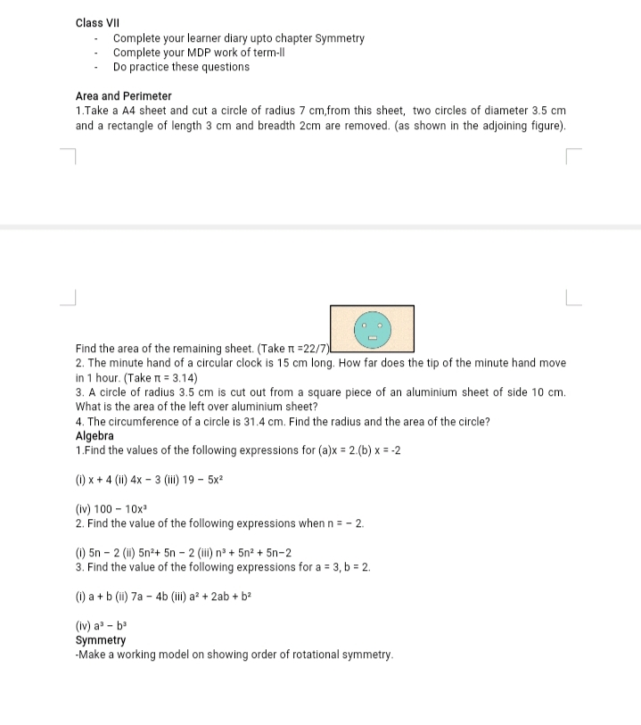
MATHS

Science
- PT -2 paper answering in A4 sheet
- Learn spelling from Reproduction,time,and measurements and electricity
Social science
- Paste the picture about Kabir and write about it
- Write 1 page about cold desert Ladakh
- Write 2 pages about doordarshan channel.
- World political map on A4 sheet

ARTIFICIAL INTELLIGENCE
Q1. Fill in the blanks:

(To be done in Book)

Answers:
- <BR>
- Heading Tag
- Ted Nelson

(To be done in Computer copy)

Q2. Differentiate Between:
Answer 2a:

<BR> tag | <HR> tag
It is used to show line break  . | It is used to add shaded horizontal lines in a web page .
Syntax:  <BR> Content | Syntax:  <HR SIZE= “VALUE” WIDTH = “PERCENT” ALIGN = “ LEFT/RIGHT/CENTER” COLOR =“ COLOR NAME “ >
Answer 2b:

Container tag | Empty tag
The tags which are used in pairs are called container  tag . | Empty tags are the stand-alone tags which are singly used i.e. not in pairs.
It is used with an opening  and a closing tag . | Such tags do not have a closing tag but only an opening tag .
Example:  <H1>………</H1> | Example:  <HR>

Q3. Write short notes on:
Answers:

HTML
HTML stands for Hyper Text Markup Language. It is a kind of language which helps to write codes to mark the contents on web pages.

Comment Tag
Comments are used to add remarks. The exclamatory sign (!) followed by (-) is used to denote comments.

Attributes
Attributes refers to the extra features that can be added to the tags to change and enhance the appearance of contents when displayed in the web page.

Footer
Footer is the last part of the body of an HTML document. Its use is optional.

Q4. Answer the following question:

Q4a.What is the significance of heading tags? Give examples in support of your answer.
Answer:
Heading tags (From <H1> to <H6>) are used to mark headings at different levels.
There are six level of the heading tags. The first level i.e. <H1> tag displays the largest size of text and the sixth level i.e. <H6> tag displays the smallest size of the text.

Q4b. Explain features of HTML.
Answer:
- Html is a cross platform language.
- Html is neither a word processor nor a programming language rather it is a markup language.
etc

Q4c. Briefly explain about the different ‘Text Highlighting Tags’.
Answer:
Some frequently used Text highlighting tags are:
- <B> The Bold Tag - It is used to display the text in bold face.

- <I> The Italic Tag- It is used to display the text in italics style.
- <U> The Underline Tag – It is used to underline the text. etc

Q4d.What are the essentials to work with HTML?
Answer:
To work with HTML, a user needs
  - Text Editor
  - Web Browser

Q4e. Explain the basic layout of html document.
Answer:
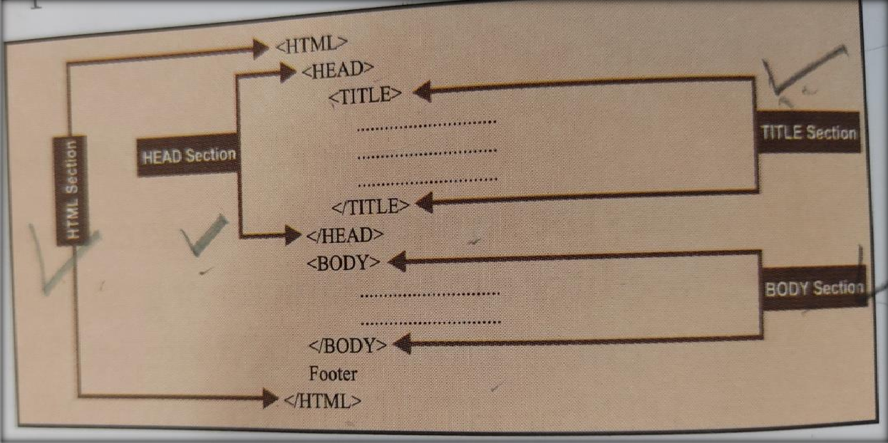

Q4f. Write the steps to create and save an HTML Document.
Answers:

Step i) Open a text editor say, Notepad or Kwrite.
Stepii) In the layout page of text editor, write the necessary codes for creating the web page.
Step iii) Save the file with an extension .htm or .html.

Step iv) Open a web browser.
Step v) At the address bar, type the name of HTML document along with its path.
Step vi) In the ‘Open’ window, click on ‘Browse’ and select the file name from its location.
Step vii) Click on ‘Open’button.

Q5. Write the syntax and function of the followingtags: -
Answer:

<HR> Tag -

It is used to add shaded horizontal lines in a web page .
Syntax:
<HR SIZE= “VALUE” WIDTH = “PERCENT” ALIGN = “ LEFT/RIGHT/CENTER” COLOR =“ COLOR NAME “ >
    - Center tag-

It is used to align the contents towards center of the screen.
Syntax:
<CENTER >… </CENTER>

<P> tag –

It is used to begin a paragraph in a web page.
Syntax:
<P> Paragraph Content </P>

    - Heading tag –

Heading tags (From <H1> to <H6>) are used to mark headings at different levels.
Syntax:
<Hn Align = “LEFT”/” RIGHT”/” CENTER” > </Hn>

<BR> tag –

It is used to show line break .
Syntax:
<BR> Content

    - Font tag –

It is used to set the text color, text size and typeface of an HTML page.
Syntax:
<FONT COLOR = “COLOR NAME”> TEXT </FONT>

Q6. What is the significance of ‘Comments’?
Answer:
Comments are used to add remarks. The exclamatory sign (!) followed by (-) is used to denote comments.

WINTER BREAK HOLIDAY HOMEWORK -2023
CLASS-VIII

ENGLISH
a) Letter to Santa: Cut the shapes related to Christmas Day ie. Jingle Bell, Christmas Tree, Star, Gift box, Sledge, and etc. Decorate it and write letter to our loving Santa Claus requesting him to fulfill your desire on this Christmas Day.
b) 01 Book Review: Write Book Review and decorate it.
c) Make a Chart ( Group Activity)
Line no. 1: Tenses
Line no. 2: Forms of Verb (50 Verbs)
Line no. 3: Formats of the following: i) Notice ii) Letter Writing-Formal and Informal
iii) Message
Line no. 4: Forms of Verb

HINDI
शीतकालीन गृहकार्य
विषय - हिन्दी
अनुच्छेद लेखन
1) क्रिसमस दिवस
2) वन महोत्सव
निबंध लेखन
1) खेल दिवस
2) अपने प्रिय खेल
नौकर पाठ
परियोजना कार्य
SANSKRIT
शब्द रुपाणि
अस्मद,युष्मद,पितृ,मातृ।
धातु रुपाणि
कृ,दृश्,स्था पाँचों लकाऱ में।

MATHS
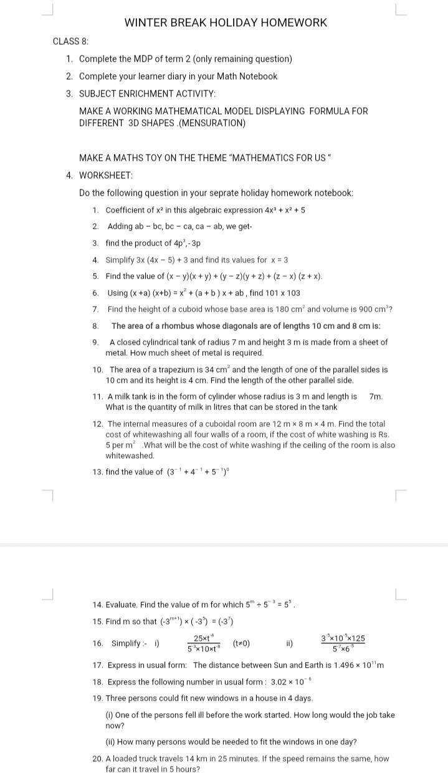

SCIENCE

1-collect newspaper cuttings on HIV/AIDS, paste on A_4, sheet, write report
2-make model of kaleidoscope
3-Read TB Lesson _Adolescence, frame 2,assertion reason, 2,mcq, 3,v short question answer

SOCIAL
MDP-Understand & locate various minerals resources in India
Use India Political Map

ARTIFICIAL INTELLIGENCE
write any two features of Python that make it user friendly.
Python is a general-purpose high-level programming language which is a a) Simple and interactive b)Platform Indipendent.
What is the difference between the interactive mode and the Script mode of Python?
In the interactive mode of python, the interpreter executes the statements one by one whereas, to write lengthy programs, we use the script mode in which we can create and edit the programs.
What is the purpose of adding a comment in the program? What are the two ways used to add the comments in Python?
comments are the statements that are added to a program with the purpose of making the code easier to understand.
How is if statement different from if…else statement?
The if statement is used to evaluate only once condition. it performs a course of action if the condition evaluates to true, otherwise its skips the statements.
Differentiate between the function of ‘+’ operator when used with integer and string values.
The ‘+’ operator when used with numbers, add the values and gives the sum as output, whereas, when the ‘+’ operator is used with string values, it concatenates two strings together.
What is the difference between the following statements?
a=10 and a==10
In the statements a=10, the variable is assigned value 10, however in the statement a==10, the value of a is equated with 10. The ‘=’ (equal to) sign in the assignment operator in Python, whereas ‘==’ sign is called equal to operator.

BASIC PYTHON PROGRAMS

- program to add two numbers
INPUT:
# Python3 program to add two numbers num1 = 15
num2 = 12
# Adding two nos sum = num1 + num2
# printing values
print("Sum of", num1, "and", num2 , "is", sum)
OUTPUT:
Sum of 15 and 12 is 27

- Find Maximum of two numbers in Python
INPUT:
# Python program to find the # maximum of two numbers
def maximum(a, b): if a >= b:
return a
else:
return b
# Driver code a = 2
b = 4 print(maximum(a, b))
OUTPUT:

4
3.To find simple interest
INPUT:
# Python3 program to find simple interest # for given principal amount, time and
# rate of interest.
def simple_interest(p,t,r):
print('The principal is', p) print('The time period is', t) print('The rate of interest is',r) si = (p * t * r)/100
print('The Simple Interest is', si) return si
# Driver code simple_interest(8, 6, 8)

OUTPUT:

The principal is 8 The time period is 6
The rate of interest is 8 The Simple Interest is 3.84

4.Find Area of a Circle
INPUT:
# Python program to find Area of a circle def findArea(r):
PI = 3.142
return PI * (r*r); # Driver method
print("Area is %.6f" % findArea(5));

OUTPUT:
Area is 78.55000
5.Check Prime Number

WINTER BREAK HOLIDAY HOMEWORK -2023
CLASS-IX
English
PRACTICE WORK for PT-2
Letter Writing – Write ONE example of Business Letter (Enquiry, Order, Complaint, Replacement and TWO examples of letter to Editor.
Story Writing - Write TWO Story Writing with the help of Picture/ Clues.
Grammar: (2 exercises for each) Editing, Omission, Jumbled Words
Literature: Write Poetic Device Poem 4-“The Seven Ages” and Poem 5-“Oh! I Wish…..”
MCB: Complete Unit-7 : Sports and Games
Learn all English written work from Fiction -4, Drama : 1 & 2, Poem- 4 & 5 for PT-2
Hindi
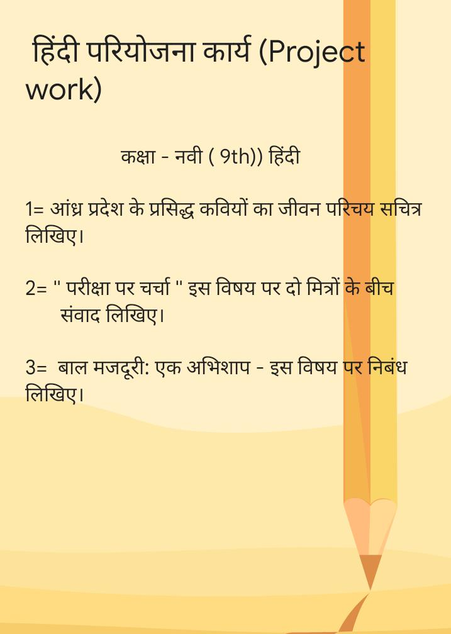

Sanskrit
शब्द रूपाणि
अस्मद,युष्मद तत्,एतत
धातुरुपाणि
भू,स्था,कृ,पठ
Maths
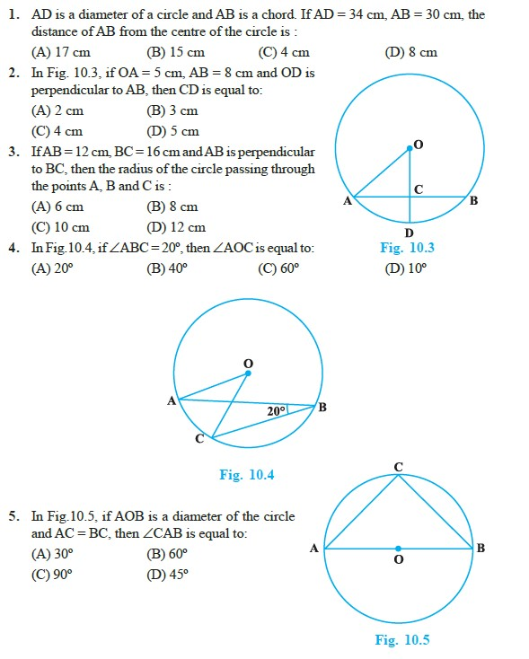

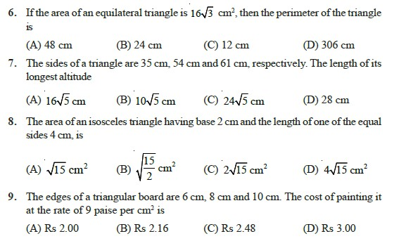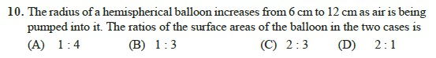

Science
1).Solve In-text and Exercise
Questions of Sound Chapter.
2). Learn the following chapters for PT 3-
i) Force and Laws of motion.
ii) Gravitation.
Social
- National population Policy 2000 (essay 2 pages )
- Map making ( Natural vegetation )
- write about 10 medicinal plants
- 1st world war & 2nd world war ( write information about it )
- Latest Policy & schemes by government for poor people
( All of these In A4 sheet )

ARTIFICIAL INTELLIGENCE
- program to add two numbers

INPUT:
# Python3 program to add two numbers num1 = 15
num2 = 12

# Adding two nos sum = num1 + num2

# printing values
print("Sum of", num1, "and", num2 , "is", sum)

OUTPUT:
Sum of 15 and 12 is 27

- Find Maximum of two numbers in Python

INPUT:
# Python program to find the # maximum of two numbers

def maximum(a, b): if a >= b:
return a
else:
return b
# Driver code a = 2
b = 4 print(maximum(a, b))

OUTPUT:

4

- Find the Factorial of a Number
INPUT:
# Python 3 program to find # factorial of given number def factorial(n):
# single line to find factorial
return 1 if (n==1 or n==0) else n * factorial(n - 1)

# Driver Code num = 5
print("Factorial of",num,"is",factorial(num))

OUTPUT:

Factorial of 5 is 120

- To find simple interest

INPUT:
# Python3 program to find simple interest # for given principal amount, time and
# rate of interest.
def simple_interest(p,t,r):
print('The principal is', p) print('The time period is', t) print('The rate of interest is',r) si = (p * t * r)/100
print('The Simple Interest is', si) return si
# Driver code simple_interest(8, 6, 8)

OUTPUT:

The principal is 8 The time period is 6
The rate of interest is 8 The Simple Interest is 3.84

- Find Compound Interest

INPUT:
# Python3 program to find compound # interest for given values.
def compound_interest(principal, rate, time): # Calculates compound interest
Amount = principal * (pow((1 + rate / 100), time))
CI = Amount - principal print("Compound interest is", CI)

# Driver Code compound_interest(10000, 10.25, 5)

OUTPUT:

Compound interest is 6288.946267774416

- Find Area of a Circle

INPUT:
# Python program to find Area of a circle def findArea(r):
PI = 3.142
return PI * (r*r); # Driver method
print("Area is %.6f" % findArea(5));

OUTPUT:

Area is 78.550000

- Check Armstrong Number

INPUT:
# Python program to determine whether # the number is Armstrong number or not # Function to calculate x raised to
# the power y def power(x, y):
if y == 0:
return 1
if y % 2 == 0:
return power(x, y // 2) * power(x, y // 2) return x * power(x, y // 2) * power(x, y // 2)

# Function to calculate order of the number def order(x):
# Variable to store of the number n = 0
while (x != 0):
n = n + 1
x = x // 10
return n
# Function to check whether the given # number is Armstrong number or not def is Armstrong(x):
n = order(x) temp = x sum1 = 0
while (temp != 0):
r = temp % 10
sum1 = sum1 + power(r, n) temp = temp // 10
# If condition satisfies return (sum1 == x)
# Driver code x = 153
print(is Armstrong(x)) x = 1253
print(is Armstrong(x))

OUTPUT:

True False

- Check Prime Number

INPUT:
num = 11
# If given number is greater than 1 if num > 1:
# Iterate from 2 to n / 2
for i in range(2, int(num/2)+1):
# If num is divisible by any number between # 2 and n / 2, it is not prime
if (num % i) == 0:
print(num, "is not a prime number") break

else:
else:

print(num, "is a prime number")

print(num, "is not a prime number")

OUTPUT:

11 is a prime number

- Print all Prime numbers in an Interval

INPUT:
# Python program to print all # prime number in an interval def prime(x, y):
prime_list = []
for i in range(x, y):
if i == 0 or i == 1:
continue
else:
for j in range(2, int(i/2)+1):
if i % j == 0:
break

return prime_list # Driver program starting_range = 2
ending_range = 7
else:

prime_list.append(i)

lst = prime(starting_range, ending_range) if len(lst) == 0:
print("There are no prime numbers in this range")
else:
print("The prime numbers in this range are: ", lst)

OUTPUT:

The prime numbers in this range are: [2, 3, 5]

- n-th Fibonacci number

INPUT:
# Function for nth Fibonacci number def Fibonacci(n):
if n<= 0:
print("Incorrect input") # First Fibonacci number is 0 elif n == 1:
return 0
# Second Fibonacci number is 1 elif n == 2:
return 1

else:

# Driver Program

return Fibonacci(n-1)+Fibonacci(n-2)

print(Fibonacci(10))

OUTPUT:
34

- How to check if a given number is Fibonacci number?

INPUT:
# python program to check if x is a perfect square
# A utility function that returns true if x is perfect square import math
def is PerfectSquare(x):
s = int(math.sqrt(x)) return s*s == x
# Returns true if n is a Fibonacci Number, else false def is Fibonacci(n):
# n is Fibonacci if one of 5*n*n + 4 or 5*n*n - 4 or both # is a perfect square
return is Perfect Square(5*n*n + 4) or is Perfect Square(5*n*n - 4) # A utility function to test above functions
for i in range(1, 11):
if (is Fibonacci(i) == True):
print(i, "is a Fibonacci Number")

OUTPUT:
else:

print(i, "is a not Fibonacci Number ")

  - is a Fibonacci Number
  - is a Fibonacci Number
  - is a Fibonacci Number
  - is a not Fibonacci Number
  - is a Fibonacci Number
  - is a not Fibonacci Number
  - is a not Fibonacci Number
  - is a Fibonacci Number
  - is a not Fibonacci Number
  - is a not Fibonacci Number

- nth multiple of a number in Fibonacci Series

INPUT:
# Python Program to find position of n\'th multiple # of a number k in Fibonacci Series
def findPosition(k, n): f1 = 0
f2 = 1
i =2;
while i!=0:
f3 = f1 + f2; f1 = f2;
f2 = f3;
if f2%k == 0:
return n*i
i+=1
return
# Multiple no. n = 5;
# Number of whose multiple we are finding k = 4;
print("Position of n\'th multiple of k in’ "Fibonacci Series is", findPosition(k,n));

OUTPUT:

Position of n'th multiple of k in Fibonacci Series is 30

- print ASCII Value of a character

INPUT:
# Python program to print # ASCII Value of Character
# In c we can assign different
# characters of which we want ASCII value c = 'g'
# print the ASCII value of assigned character in c print("The ASCII value of '" + c + "' is", ord(c))

OUTPUT:

("The ASCII value of 'g' is", 103)

- Sum of squares of first n natural numbers

INPUT:
# Python3 Program to # find sum of square # of first n natural
# numbers
# Return the sum of # square of first n
# natural numbers def squaresum(n):
# Iterate i from 1 # and n finding
# square of i and # add to sum. sm = 0
for i in range(1, n+1):
sm = sm + (i * i)
return sm
# Driven Program n = 4
print(squaresum(n))

OUTPUT:
30

- cube sum of first n natural numbers

INPUT:

# Simple Python program to find sum of series # with cubes of first n natural numbers
# Returns the sum of series def sumOfSeries(n):
sum = 0
for i in range(1, n + 1):
sum += i * i*i return sum
# Driver Function n = 5
print(sumOfSeries(n))

OUTPUT:

225

